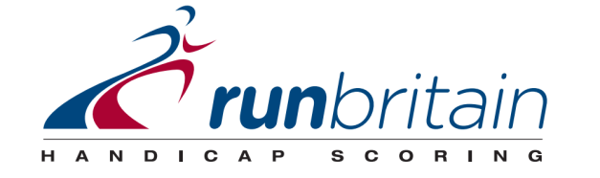

Dear Runner
Clowne Half Marathon 22nd November 2015

Congratulations on completing the race. Ours is a runbritain-licensed event and therefore your time is included in calculating your free runbritain handicap score. More than 50,000 runners of all standards have now claimed their runbritain handicap score. As well as giving you a current score, between scratch and 36, your free personalised running biog page includes your current national ranking, your position on the national ladder, your progress graph, your strongest distance, a head-to-head comparison with other runners and downloadable training schedules to improve your score next time you race. Your handicap score also updates automatically every time you complete a licensed event. To claim your score now, click on http://www.runbritainrankings.com/user/claimhandicap.aspx

Should you have any queries then please do not hesitate to contact me

Many thanks,

The runbritain team

